‘

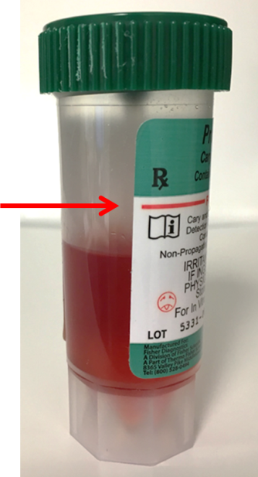
Stool Collection in Carey Blair Vial

- Collect stool specimen in a clean, dry, wide-mouthed container. Using the spoon built into the cap, small samples of stool should be added to the liquid in the vial, especially areas that look bloody or watery. Place stool in vial within two hours of passing.
- Add enough sample to raise the liquid level to the red fill line on the label. Use the spoon to mix the sample. Recap the vial, making sure that the lid is securely fastened. Firmly shake vial until the contents thoroughly.
- Label vial appropriately with first name, last name, date and time of collection, and date of birth.

